Quick Guide :
Timesheet Adjustment

Document Category:

Rev. | Date  (28 Sept 2010) | Author  Luc GIROUX | Checked  (Name) | Approved  (Name) | Status

Revision History
Rev. No. | Revision Date | Revision Detail

Table of Contents
1. Introduction 4
2. Application access and rights 5
3. The application 6
3.1 Looking for a timesheet 6
3.2 Search Results 7
3.3 Edition of a timesheet 8
4. Adjustment example : change of CTR code 10

Introduction

The goal of this documentation is to help users to understand and use the “Timesheet Adjustment” module.
This module, which is present in the form of a tab in the “Timesheet approval application”, allows to perform adjustments on timesheets accordingly to certain conditions we will see later in this document.

Application access and rights

Only users granted with right « TS Adjustment Read» or« TS Adjustment Write» can access the application. This rights are given through the “manage filter” tab in the « Timesheet Approval » application.

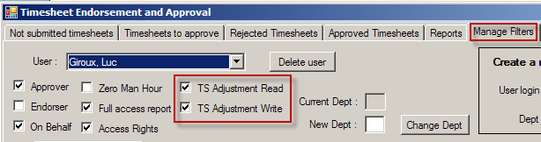

The « TS Adjustment Read» right allows a read only access to the « Timesheet adjustment » tab whereas the TS Adjustment Write» allows a write access.

The application

Looking for a timesheet

The search of a timesheet is done according to the following criterias :
- EmployeeId + Year + Week
OR
- EmployeeNo + Year + Week
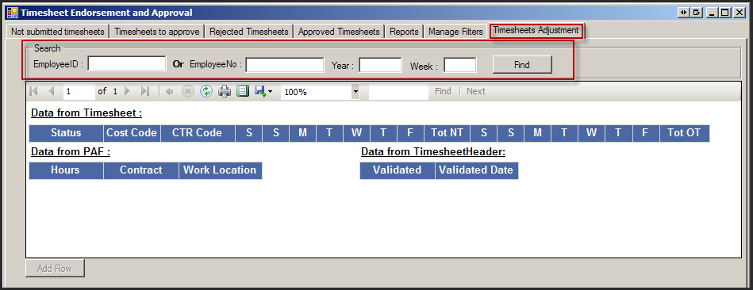

Search Results

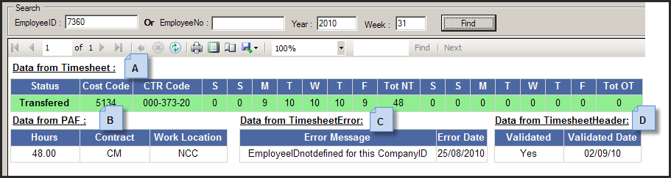

Details of the various tables:

- A: Represent data from the Timesheet system. Possible statuses are the following :
  - 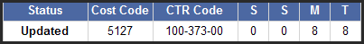: The TS has been saved but not submitted.
  - 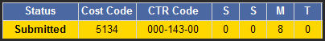 : TS has been submitted but not approved.
  - 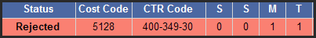 : TS has been rejected.
  - 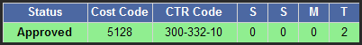 : TS has been approved.
  - 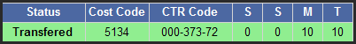 : TS has been approved and transfered to PAF.
- B: Represent data from the PAF application.
- C :Fatal errors list of the timesheet. If the timesheet never had fatal error, this table does not appear.
- D : Allow to know the current state of validity of the timesheet : a timesheet may have been in error, the errors will be listed in the C table, but if it has been fixed, it then appears as valid.

Edition of a timesheet

A timesheet is editable, i.e the « add row » button is enable, only if all the following condition are valid :
- The user must be granted the « TS Adjustment Write »
- La timesheet « Approved » flag must be equal to 1 : the timesheet has been approved and transferred or not to PAF.
- The date of the timesheet must be include in the last 4 months before the first of month of the last invoice not closed.

A clic on the « add row » button will display input fields :

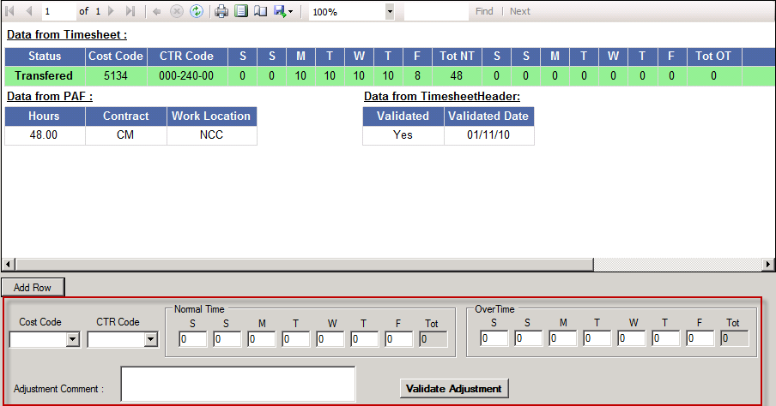

Once the seizure is finished, we just have to clic on the « validate adjustment » button to finish the adjustment. A message box will then appear and the data are refreshed:
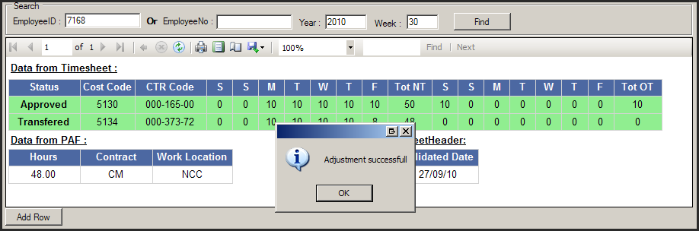

Adjustment example : change of CTR code

Let’s take the following example : the timesheet below has been approved and transferred to PAF, however the CTR code is not correct:
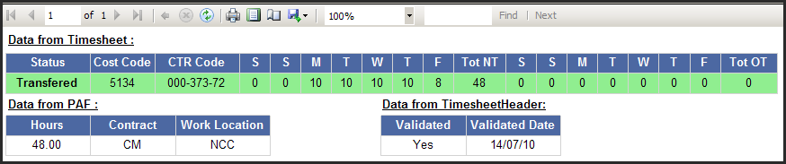
Here is how to process in order to change the CTR code :
We clic on the « Add Row » button and we add the following row :
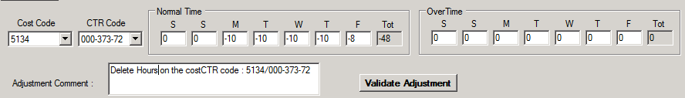

We validate by clicking the « Validate Adjustment » button.
Then we add hours on the correct CTR Code :
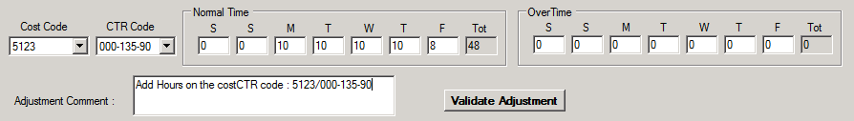

We validate again : changes have been performed :
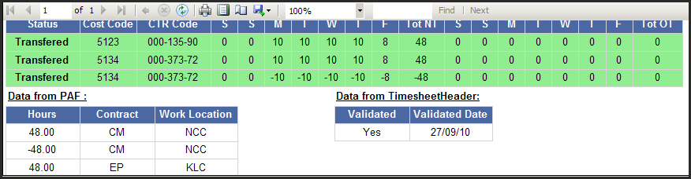

End of Document

